Elevator Week 2: Controller Design

**Objective**: Implement a controller to drive the elevator to a desired height

**Deliverables:**

1.) Demonstration allowing user to set elevator height in inches, elevator responds

2.) Plot comparing actual elevator height to desired height over time

This week you will design the controller block. You will evaluate how effective your controller is by treating the **entire system** as a single block with an input (desired height) and output (actual height). A good controller will make the output match the input.

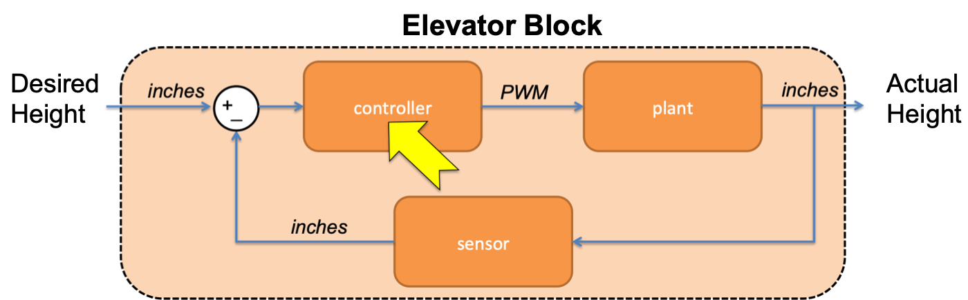

**Deliverables are due at the beginning of next lab period**

**Step 1: Write a Controller**

Write a function in your mbed program to set motor speed based on the error between the desired height and the actual height of the elevator. The function should accept one float and return one float. That is, the declaration should be:

**float** controller(**float** error);

If the elevator is too high, the motor should unwind with a PWM value of -0.15. If it is too low the motor should wind up, this requires more energy so use a PWM value of 0.55. Your function should have a single if/else clause.

**Step 2: Put it all together**

In the main function implement the following pseudo code:

do forever:

read in desired_height and num_iterations

for num_iterations:

actual_height = convert(sensor.read())

error = desired_height - actual_height

pwm_dutycycle = controller(error)

motor.speed(pwm_dutycycle)

wait(0.02) //run 50 iterations per second

print actual_height, duty cycle

Use TeraTerm or MATLAB to inspect the data and make sure your code operates correctly. When you enter the desired height and number of iterations, the elevator should move in the right direction.

*Deliverable:*

Demonstrate your elevator control system to your instructor. Do not worry if your elevator does not work very well. *We will improve it next week ☺*

**Step 3: Evaluate the controller using MATLAB**

Write a script in MATLAB to send the elevator to 12”, then to 18”, and finally back to 12” with 250 iterations for each step. The entire program should run for 15 seconds.

Collect the height and duty cycle data over serial and produce a plot with two lines showing the actual elevator height and the desired elevator height over time. The difference between the desired and actual heights is the error. A good controller will have smaller error.

*Deliverable:*

Plot the entire elevator run as described. Make sure the plot has a legend, title, and axis labels. In a few sentences describe the limitations of your controller.